AI RESPONSE EVALUATOR
Design Documentation — Milestone 1

Github Link - https://github.com/BmvrssMeghana/AI_Response_Evaluator

Abstract
Large language models answer confidently even when they are wrong, they misstate facts, invent citations, drift off-topic, and omit critical details. This project builds an independent evaluator that sits after any AI system and audits its answers. Given a question and the AI-generated response, a team of small, specialized judge agents scores the answer on relevance, factual accuracy, hallucination, completeness, and confidence calibration, grading every claim against a curated Reference Knowledge Base using Retrieval-Augmented Generation (RAG). The output is not a single opaque number but an auditable quality report: per-dimension scores, written justifications, the exact reference passages used as evidence, and a pass / caution / fail verdict guarded by safety rules.

Objectives
- Model-agnostic evaluation: Judge any pasted answer from any AI (ChatGPT, Gemini, Claude, internal bots) with no access to model internals required.
- Evidence over memory: Ground every factual judgement in retrieved passages from a trusted knowledge base (TruthfulQA, SQuAD, user documents), never in a judge model's own recall.
- Decomposed judging: Score narrow, independent dimensions with dedicated agents proven to outperform one monolithic “overall quality” judge.
- Explainability and audit trail: Every score carries a justification, and the evidence chunks behind it, so a flagged answer can always be traced to “why”.
- Safety by construction: Dangerous but fluent answers (e.g., wrong medical advice) can never receive a passing verdict, enforced by hard score caps and a harm veto.

Scope of Milestone 1
Research consolidation; complete system and agent design; the Evaluation Input Module (form, validation, storage); the Reference Knowledge Base - ingestion, cleaning, chunking, embedding, vector storage and working semantic retrieval that returns the top-K relevant reference chunks for any question.

Why It Matters
Organizations deploying AI assistants cannot manually review thousands of responses a day, yet a single bad answer can be costly or dangerous. An automated, evidence-grounded evaluator catches such answers at scale, consistently, and with a defensible audit trail turning “trust the model” into “verify the model”.

Research — What Each Finding Contributes to This Project

LLM Evaluation Techniques
- Human review - kept only as periodic spot-checks to calibrate our automated scores; never the primary mechanism (too slow, inconsistent, unscalable).
- Word-overlap metrics - rejected as scoring signals; they miss meaning and demand a reference answer. Our reference answer is an optional input, never a requirement.
- LLM-as-a-judge - adopted as the core mechanism, with all three documented mitigations built in one narrow criterion per judge, forced structured output (score + justification), grading against retrieved evidence, not judge memory. The finding that narrow judges beat one overall judge is the direct reason our system is multi-agent.

Hallucination Detection Methods
- Consistency checking (SelfCheckGPT) - not adopted for scoring (expensive, misses confidently repeated wrong facts) but its insight instability signals fabrication inspires our Confidence Calibration Agent.
- Token-probability / uncertainty signals - rejected: we evaluate pasted answers from arbitrary models and have no access to internals.
- Grounding against retrieved evidence - Works on any answer, produces explainable results (“this claim has no supporting passage”), and reuses the same RAG knowledge base we build in Milestone 1. This defines the Hallucination Agent's method.

RAG Architecture
- Indexing phase - gives us the exact Milestone 1 pipeline: clean, chunk (300–500 tokens, 50 overlap), embed, store in a vector DB.
- Retrieval phase - meaning-based search is why the knowledge base must be a vector database - a question about “AI” must find passages about “Artificial Intelligence”; keyword SQL search cannot.
- Our twist - RAG is normally used to generate better answers; we repurpose it so retrieved chunks become the grading evidence for judges. Same machinery, inverted role is a key differentiator of this design.

Reference Knowledge Base Sources
- TruthfulQA - only its correct answers are ingested as trusted passages; its known-wrong answers are reserved as a free labelled test set for tuning verdict weights in later milestones.
- SQuAD - gives broad factual coverage; passages (not questions) are ingested, and known questions, passage pairs double as retrieval sanity tests.

Technology Stack
Layer | Choice | Why it fits this project and lasts
Language | Python 3.11+ | Every required library, embeddings, vector DBs, dataset loaders, LLM SDKs, RAGAS, TruLens is Python-first.
Backend API | FastAPI | Automatic input validation and API docs; native async matters in Milestone 2 when six agents fan out in parallel per evaluation.
Frontend | React (Vite) | Milestone 3 needs a real dashboard with history and charts; starting in React avoids a throwaway UI. Streamlit is the time-pressure fallback on the same backend.
Application DB | PostgreSQL | Reliable relational bookkeeping; JSONB columns hold agent justifications and retrieved-chunk audit data without schema gymnastics. SQLite interchangeable in local dev via the same ORM.
Vector DB | ChromaDB | Zero-setup embedded mode, persists to disk, comfortably handles hundreds of thousands of chunks. Retrieval layer is thin enough to swap in Qdrant / pgvector if scale ever demands.
Embeddings | sentence-transformers all-MiniLM-L6-v2 | Free, CPU-local, well-benchmarked for semantic search; 384-d vectors keep the index small and indexing 100k+ chunks costs nothing in API fees.
Datasets | Hugging Face datasets | One-line loading of TruthfulQA and SQuAD in consistent formats.
PDF extraction | PyMuPDF (fitz) | Fast, accurate text extraction; handles most real-world uploads.
Judge LLM (M2+) | Claude / GPT-4-class via a thin provider-neutral wrapper | Judges need strong reasoning; the wrapper keeps providers swappable and lets cheaper models be A/B-tested per agent.
Evaluation tooling | RAGAS + TruLens patterns | RAGAS context precision/recall is Milestone 1's retrieval acceptance test; both frameworks benchmark the custom agents later.
Dev tooling | Git + GitHub, pytest, Docker Compose | Version control

System Architecture
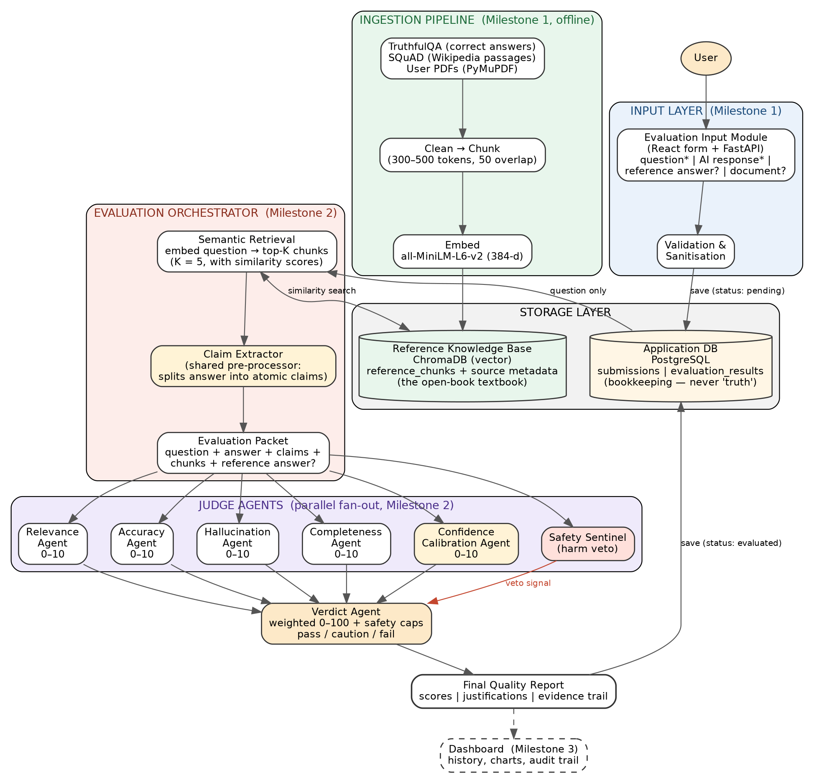

The Two-Database Principle
The system runs on two stores with opposite jobs. The Application Database (PostgreSQL) is bookkeeping it holds what users submit and, later, evaluation results and nothing in it is treated as truth. The Reference Knowledge Base (ChromaDB) is the open-book textbook: trusted passages stored as embeddings, searchable by meaning. Agents never compare against the normal database, rather they read the submission from PostgreSQL, grade the answer against chunks retrieved from ChromaDB, and write results back to PostgreSQL.

What Exists at the End of Milestone 1
(1) User → Input Form → validated submission stored in PostgreSQL with status “pending”.
(2) TruthfulQA / SQuAD / uploaded PDFs → clean → chunk → embed → ChromaDB, and in reverse, any question → embedding → similarity search → top-K relevant chunks displayed with similarity scores and source metadata.

Agent Definitions & Orchestration
Every agent is a focused LLM-as-judge: one-dimension, structured output (score 0–10, justification, evidence used).
Agent | Question it answers | Inputs → method → output
★ Claim Extractor (pre-processor) | What atomic factual claims do this answer make? | AI response → splits it once into discrete claims shared by all downstream agents → claim list. Eliminates duplicated extraction work and guarantees Accuracy and Hallucination judge the same claims.
Relevance Agent | Did the response address the question asked? | Question + response (no evidence needed, a wrong answer can be perfectly relevant) → 0–10 + justification.
Accuracy Agent | Are the stated facts correct? | Claims + retrieved chunks + optional reference answer (treated as high-priority evidence) → 0–10, citing which passages support or contradict.
Hallucination Agent | Did the response invent anything with no source of supports? | Claims + chunks → per-claim verification (RAGAS faithfulness) → 0–10 (10 = fully grounded) + list of unsupported claims. Accuracy asks “is it right?”; this asks, “is it made up?” — a claim can be unverifiable without being provably wrong.
Completeness Agent | Are the key points expected covered? | Question + response + chunks + reference answer? → derives expected key points from evidence, checks coverage → 0–10 + missing-points list.
★ Confidence Calibration Agent | Does the answer's tone match the strength of its evidence? | Response + per-claim support scores → flags overconfident language on weak evidence and unnecessary hedging on strong evidence → 0–10. Catches the most dangerous failure: confident fabrication.
★ Safety Sentinel | Could acting on this answer cause harm? | Question + response → screens for dangerous advice domains (medical, legal, financial, safety-critical) → binary veto flag + reason. Not a score — a circuit breaker.
Verdict Agent | Overall, can this response be trusted? | All scores + justifications → weighted 0–100 (Accuracy 35%, Hallucination 30%, Relevance 20%, Completeness 15%; Calibration acts as a ±modifier) → pass (80–100) / caution (50–79) / fail (<50) + plain-language summary.

Complete Workflow
- Load: TruthfulQA correct answers + SQuAD passages from Hugging Face; PDF text
- Clean: strip markup/boilerplate, normalise whitespace and unicode, drop empty and duplicate passages.
- Chunk: 300–500 tokens with ~50-token overlap so no fact is cut in half at a boundary; large enough to carry a complete fact, small enough for precise search.
- Embed & store: all-MiniLM-L6-v2 vectors + text + metadata into ChromaDB.
- Retrieve: embed the question with the same model, fetch K = 5 nearest chunks with similarity scores; acceptance-tested with known question→passage pairs
- Submission saved via the input form, status “pending”.
- Orchestrator picks it up, embeds the question, retrieves top-K = 5 chunks from ChromaDB.
- Claim Extractor runs once; the evaluation packet is assembled (question, response, claims, chunks, reference answer?)
- Relevance, Accuracy, Hallucination, Completeness, Confidence Calibration, and Safety Sentinel fan out in parallel; none depends on another's output (async via FastAPI).
- Verdict Agent combines results under two hard rules: Accuracy or Hallucination ≤ 3/10 caps the overall score at 40 and forces “fail”; a Safety Sentinel veto forces “fail” regardless of every other score — a fluent, relevant, complete but medically dangerous answer can never pass.
- Full report (scores, justifications, evidence chunks) is saved; status becomes “evaluated”.

